Mini project: Class diagram

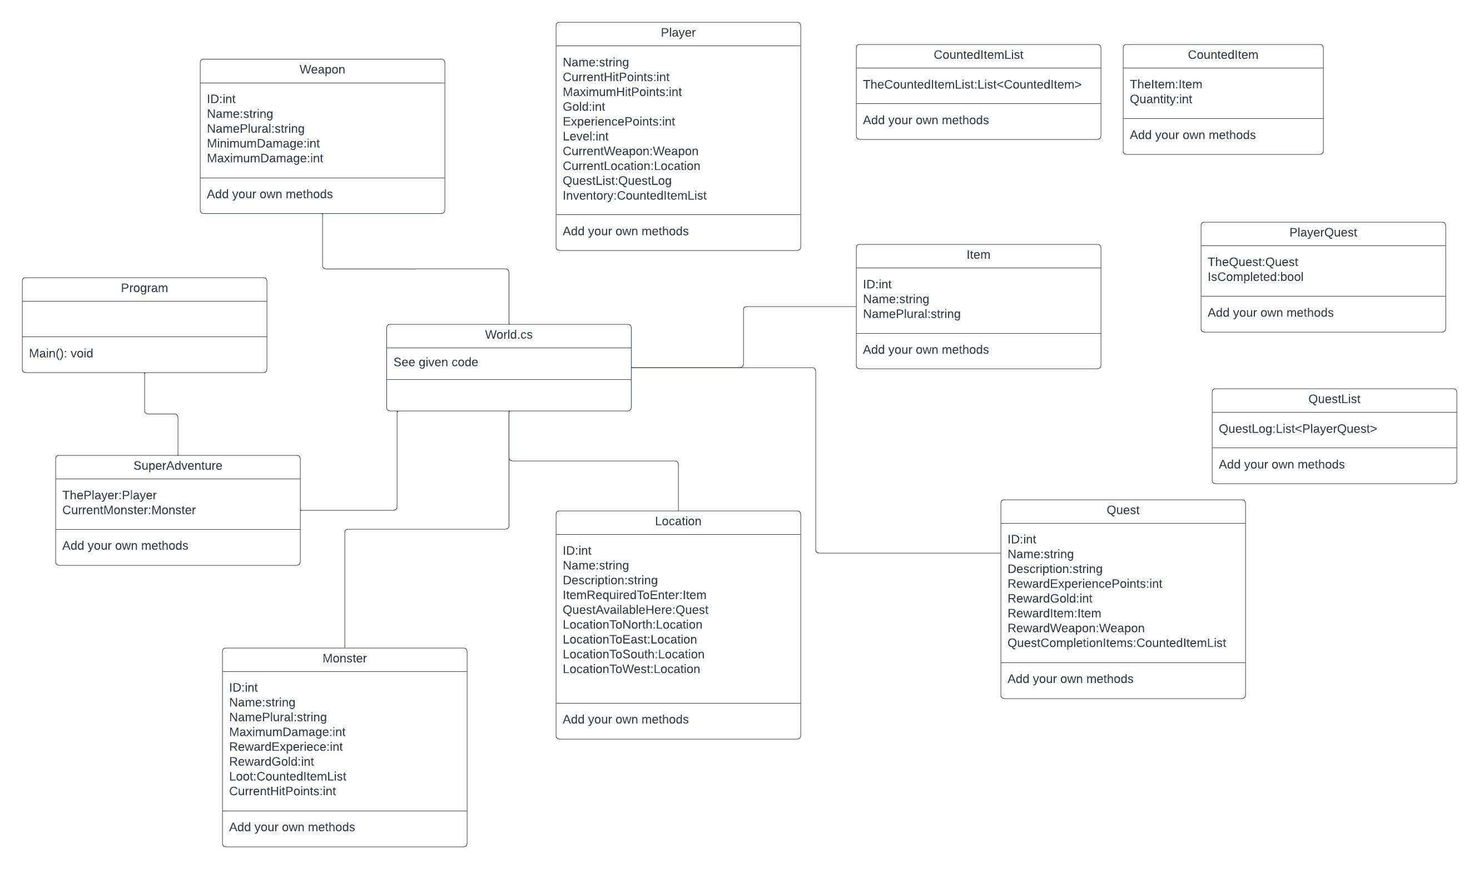

This class diagram is an example, made by an experienced programmer. Not all relationships are mapped out. This class diagram gives a quick starting point based on World.cs. Take it as an inspiration but don’t blindly copy everything. Use your own knowledge to work out the best way to program an application like this with the knowledge you have at this moment, so feel free to make any adjustments. The diagram includes optional functions like ExperiencePoints, Gold, Level etc; don’t start coding these functions until everything else works.